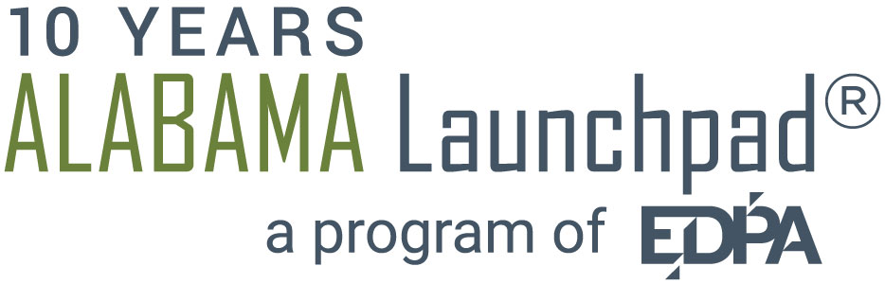
This cover form and your poem must be submitted by email to Jessica Moody, jessica@createbirmingham.org on or before April 11, 2016. Submissions will be accepted until 12:00 AM Central Standard Time.
TYPE OR PRINT VERY CLEARLY
1. | POET’S NAME:
2. | EMAIL ADDRESS:
 | EMAIL ADDRESS:
 | If you are a student or faculty member and your primary contact information is different than during the school year, please provide both email addresses.
3. | FULL MAILING ADDRESS:
4. | IF YOU ARE A STUDENT AND YOUR MAILING ADDRESS IS NOT IN ALABAMA, PLEASE PROVIDE YOUR SCHOOL ADDRESS:
5. | TITLE OF YOUR POEM:
6. | VERIFICATION STATEMENT:  Entry implies your close review and acceptance of all rules and conditions of the contest as published in the Third Annual Poetry Contest rules as well as the following: that the work submitted is original, whether published or unpublished, belonging to the poet submitting; that the decisions of the judges at each stage of the competition are final; that if you are unable to attend the reading events, you are obligated to inform the contest organizer as soon as possible so that another poet may have the chance to compete; that, to win any prize, you must be present to read; and that, to accept the top prize, you must be able to accept the award and read your poem on August 31, 2016.
I have read and agree to both the contest rules and the verification statement.
POET’S SIGNATURE:
DATE SIGNED:

